Create your own chatbot with Azure

Roland Fontanes
Table des matières
Introduction 3
What is a chatbot? 3
What method? 3
Azure AI Foundry 5
Python Configuration: 7
Streamlit app 9
Conclusion 9

Introduction
Nowadays, with the democratization of Artificial Intelligence, chatbot are everywhere. You might already use them at work for coding or specific templates, or in your personal life for a recipes or some decoration ideas. I am found of Data and AI, so I always wanted to try creating one, but never had the chance to do so. But recently I got a really interesting proposition for an internship where my job would be to optimize their intern chatbot. So let’s try to make one ourselves to see what we are capable of.

What is a chatbot?
I already knew what was a chatbot before, but let’s search on Google: “What is a chatbot?”. For IBM (https://www.ibm.com/think/topics/chatbots) : “A chatbot is a computer program that simulates human conversation with an end user. Not all chatbots are equipped with artificial intelligence (AI), but modern chatbots increasingly use conversational AI techniques such as natural language processing (NLP) to understand user questions and automate responses to them”.

This is a long and great definition so let’s try to understand each part.
First, we will code something that interact with the user and answer and/or discuss with it.
Then, AI is not mandatory, for example you can have a code like this one : https://p5js.org/tutorials/criticalai4-no-ai-chatbot. Every questions and answers are already typed in the code and the chatbot only display the corresponding text. But we do not want that, we want something that really create a new answer each time and which can answer to almost an infinite quantity of questions.
Last but not least, here we will not need to understand Natural Language Processing (NLP) but this is a really important part of chatbots. How does my computer understand what I am asking him? Does it translate my language into a programming language? Into assembly? Well, that’s where NLP comes in, it allows computers to process and interpret human language in a way they can use to generate relevant answers. First it breaks your text in small parts (words, sub words, etc…) called tokens. These tokens are converted into numerical vectors, the closer the words are, the closer the vectors are. Then Large Language Models (LLMs) such as GPT (Generative Pre-trained Transformer) analyze these vectors to understand the context, relationships between words, and your intent. They can then generate a coherent, human-like response based on what they’ve learned from billions of examples during training.

What method?
Know that we know what is a chatbot, let’s create one. So, like before, let’s search on the Internet: “How to create a chatbot?”.
First, I found Rule-based Chatbots, the simplest ones. Those are the one we discuss about before, with no AI, and only predefined rules such as: if the user ask “how are you” -> answer “I’m fine thank you, what about you?”. This is too simple and cannot handle a large panel of questions.
Then, we have Retrieval-based chatbots, here, there is not only predefined rules, we also retrieve information from a database or documents to answer the question. The most popular one is Retrieval-Augmented Generation (RAG): you ask the question, the chatbot uses embeddings to find relevant parts of your documents, it sends the question and your relevant parts to a LLM and this last one generates a great answer with enough context and/or references.
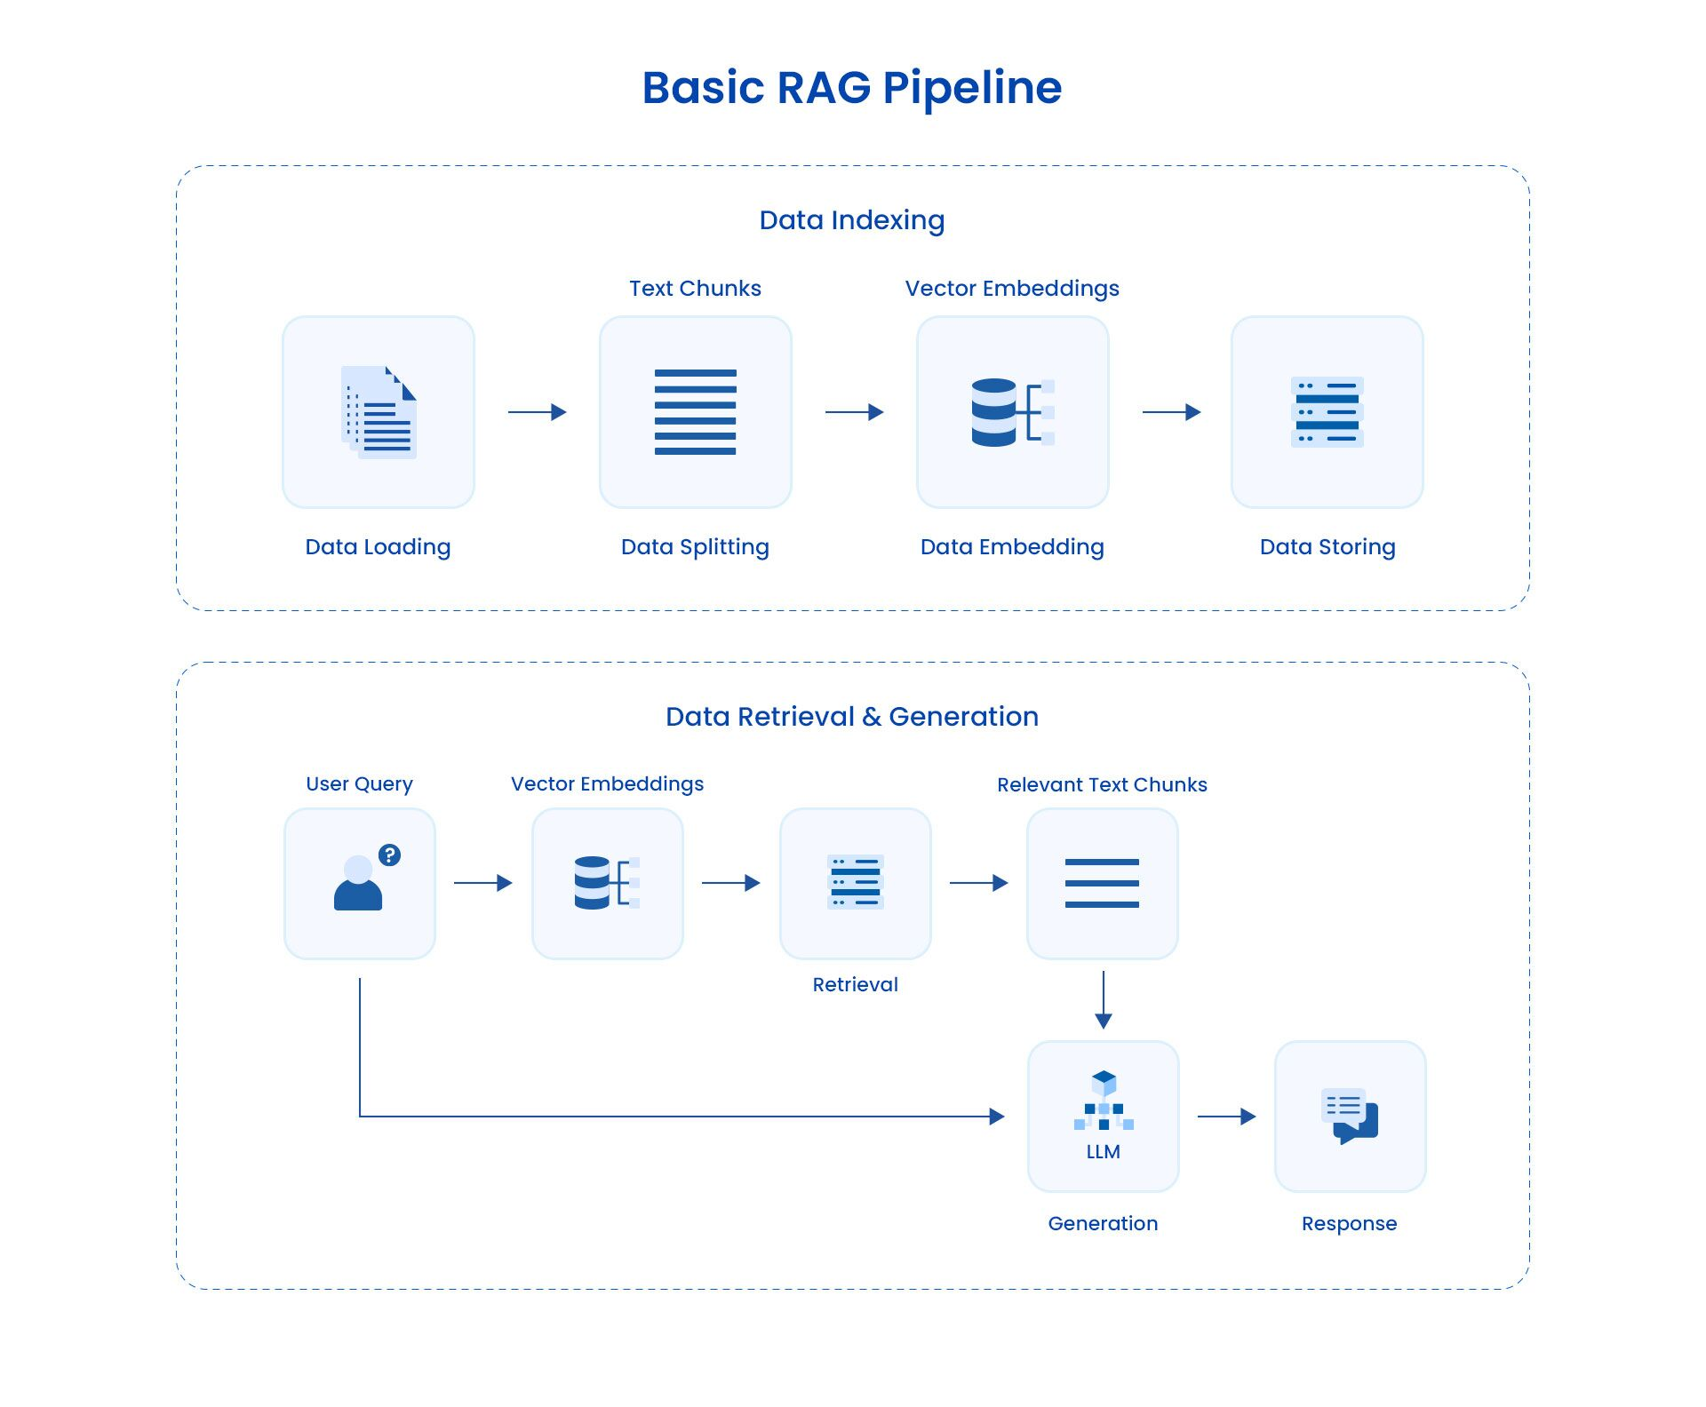
Figure 1 : Comment un pipeline RAG transforme vos données en découvertes, https://www.astera.com/fr/type/blog/rag-pipeline, 2025

Finally, Generative Chatbots like GPT, Gemini, or Claude (you may have heard of these names) does not retrieve data but generate an answer with what they learned in the training. They have already been given a tone of information and don’t need documents to answer you. But they, are much more difficult to create for an individual as you need a tone of calculus power and information.
In this project, we need a natural and efficient chatbot, without a complex installation. This is why I choose the RAG Pipeline. If you understood well to that point, you need data (.json, documents, .pdf, .txt, etc…) that you can get on your own on the internet but also a working LLM, fortunately, Azure is here for us.

Azure AI Foundry
Azure is a Microsoft cloud based platform that allows users to create, deploy and manage computing services (SaaS, IaaS & PaaS). Those services are linked and are various: virtual machines, databases, web apps and many more. Moreover, it also provides Machine Learning and AI solutions with Azure AI Foundry.
Azure Ai Foundry, includes Azure OpenAI service which gives the user access to many models such as GPT-4 and text-embedding-3-large which we will use in this project.
To create your two models you simply register into Azure Foundry (https://ai.azure.com) , and then you need a subscription and remember if you are a student this app will be free of any charge. Then you click on create new and you will end up on this small page (Figure 2). By clicking on next you will be on this second page (Figure 3) and here you will have to choose the parameters of your project, I have no recommendation, except for the Region part. Some Region may not be compatible and Azure will give you an error if you try to create your project. If you encounter this issue, make sure to select East US, East US 2, West US or even Sweden Central.
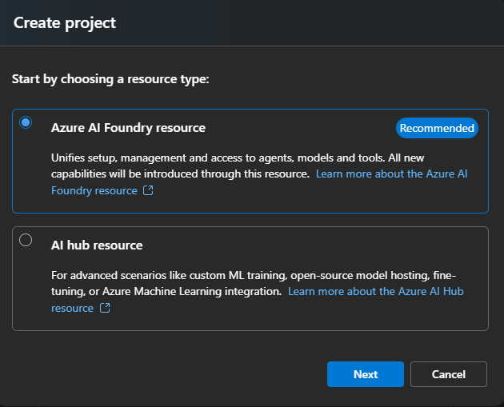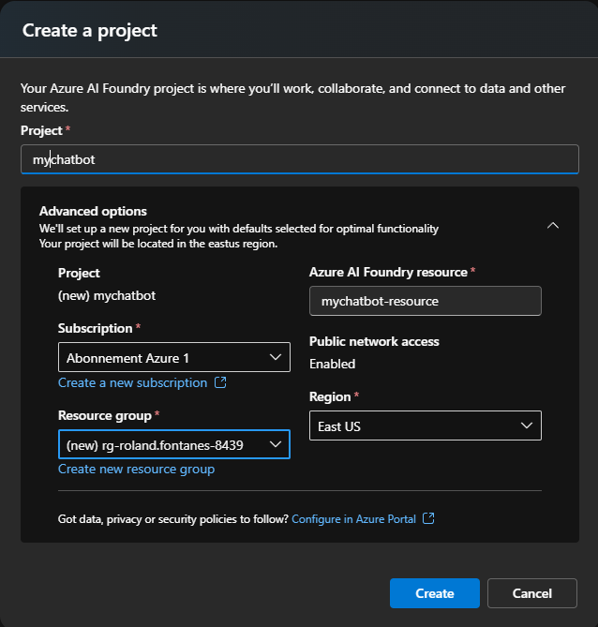
Figure 2 Figure 3
You will end up on this page : 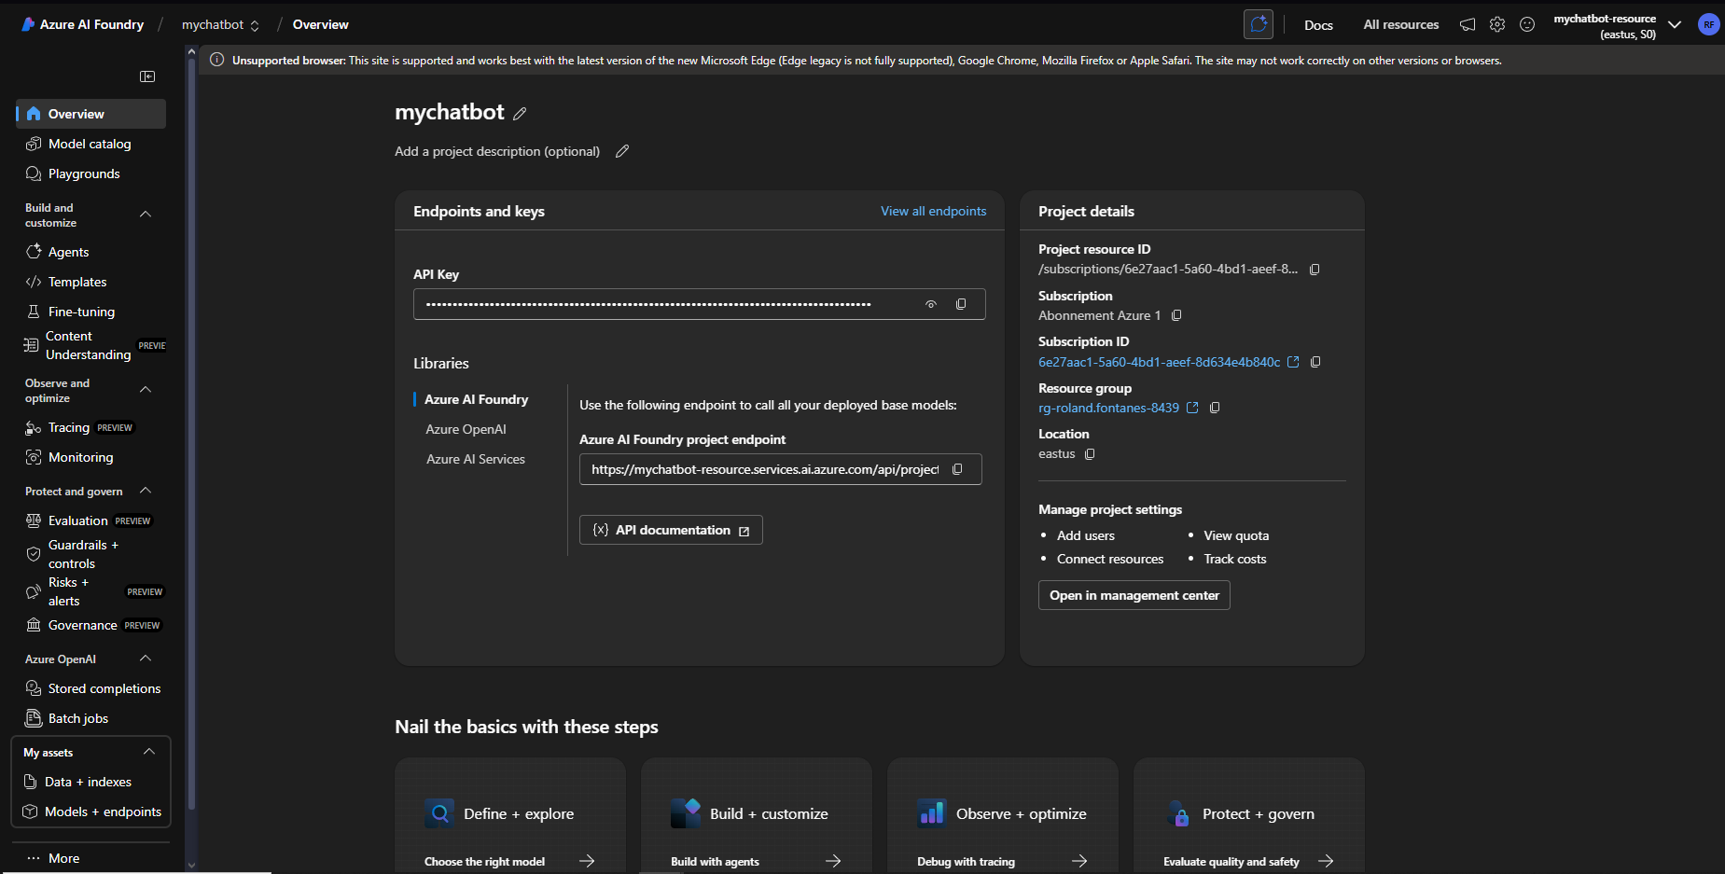
Make sure to note your API Key and Azure AI Foundry project endpoint because we will need them afterwards.
Then, click on Model catalog in the sidebar and in the search bar at the bottom, type ‘gpt-4o-mini’ and select the corresponding model. You are now here : 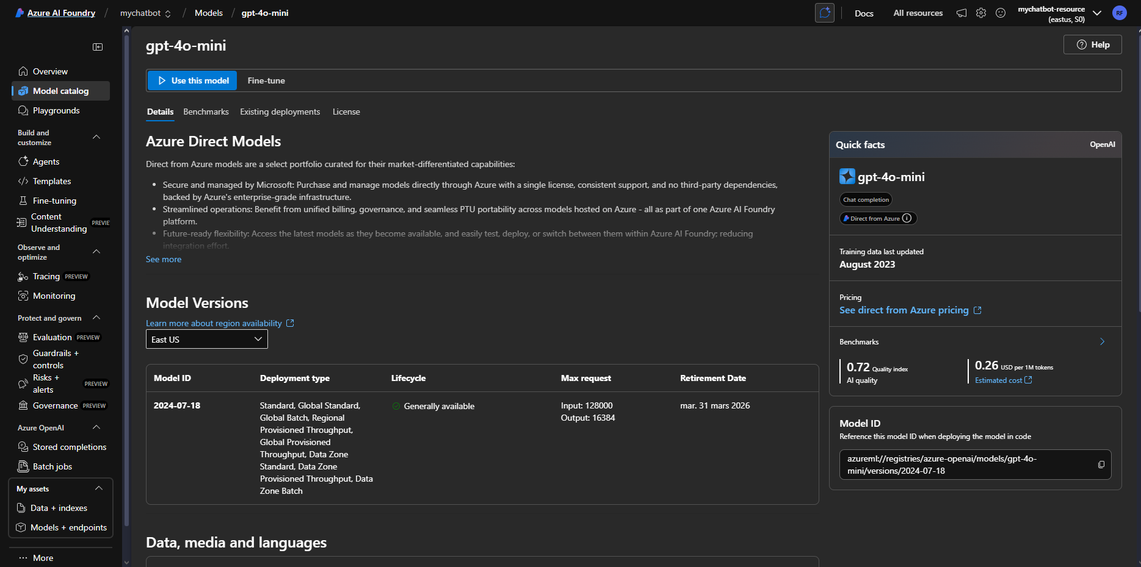
Click on “Use this model” and then “Deploy”. Now redo the same steps from Model catalog but for the model called “text-embedding-3-large”. So now in the sidebar, in “Models + endpoints” you should have this : 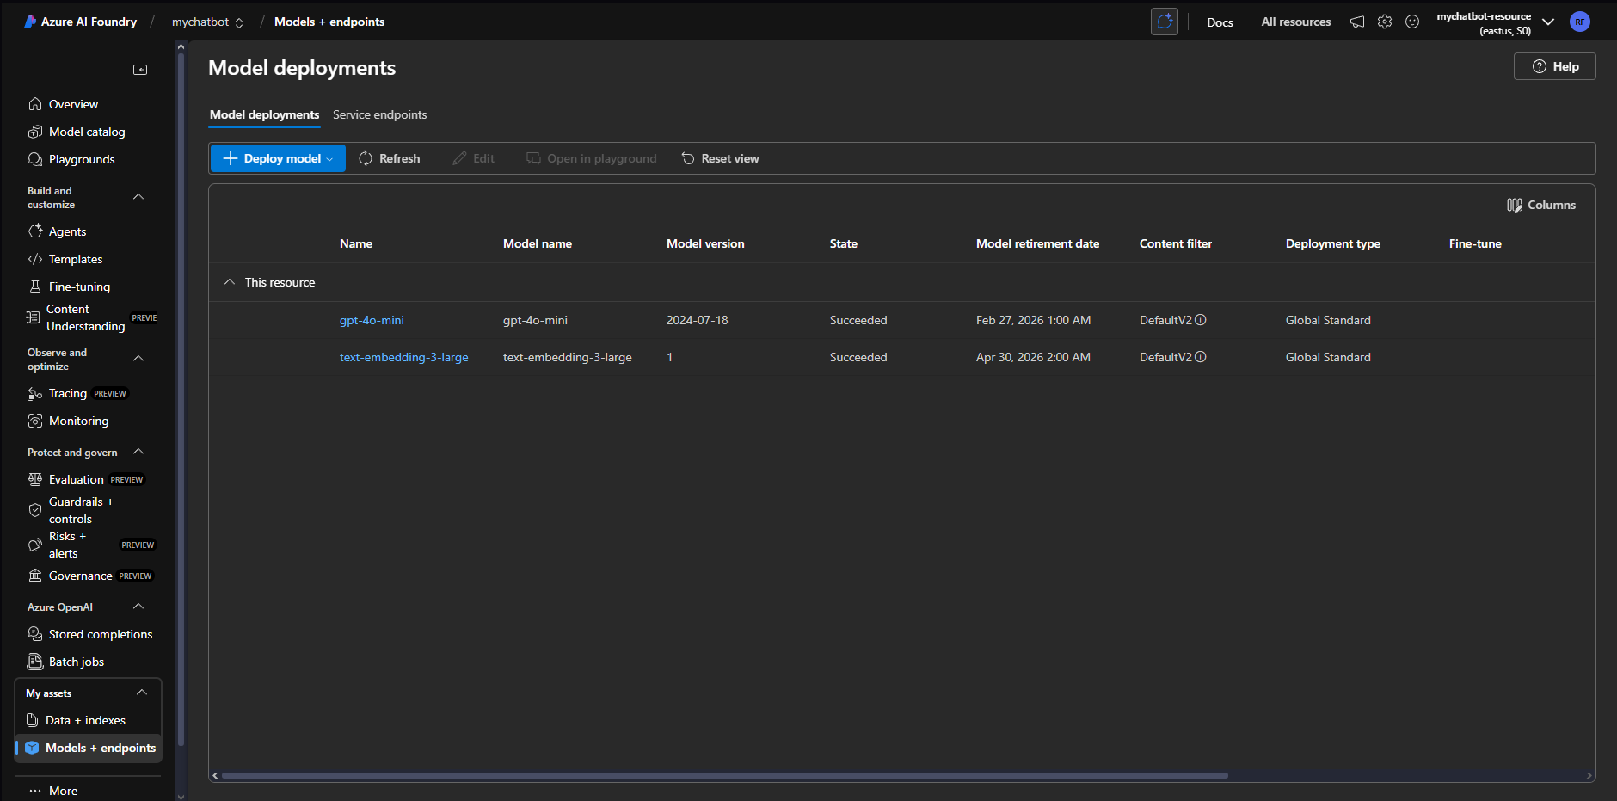

Python Configuration:
So the python app is divided in 2 parts: The Rag system and the Streamlit part. Here we are going to focus on the RAG pipeline.
If you are in a rush, the first thing you are going to do is copy paste your API key and your API endpoint that we save before into the .env file : 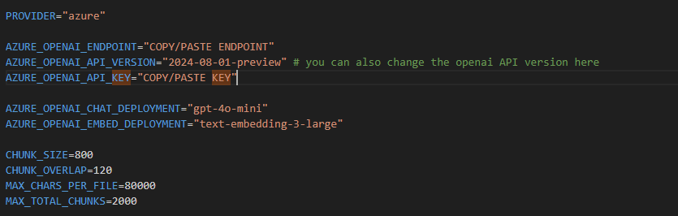
Next, you are going to fill the data folder with as many files as you want on a certain subject or something you want your chatbpot to be able to answer. Then as indicated in the readme you run the ingest.py and then the streamlit app (read README.md for detailed infos).

If you want to understand more the code I advise you to explore the app/rag.py where we will first search in data the right parts to build our context with embed_texts(), load_index(), search() and build_context(). The index is here used to not always go again to the same parts of the text and have a sort of reference that we can access faster.
After that, in the prompts.py, that you can modify, you have the prompt that will be send to the LLM. With context, task and format : 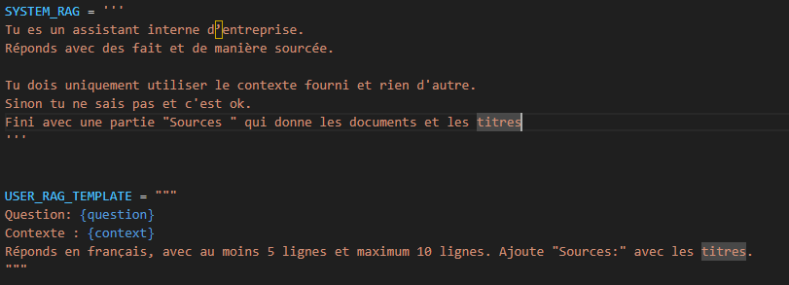
The format is here SYSTEM_RAG and is composed of the persona (Company assistant) and the format (answer to the question, with detail sources, in English and by using only the given context)
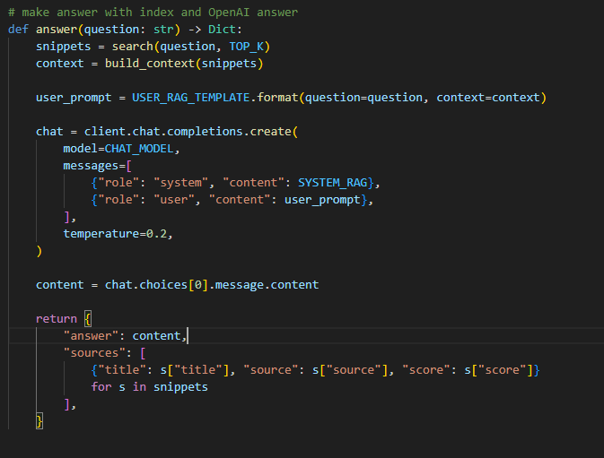
Finally, we send the whole ‘context + question’ and then build the answer in rag.py with this function:

Streamlit app
The Streamlit app is really basic, feel free to adapt it for your needs. So you can find the main file in ui/streamlit_app.py. The display is very simple and is only made with this : 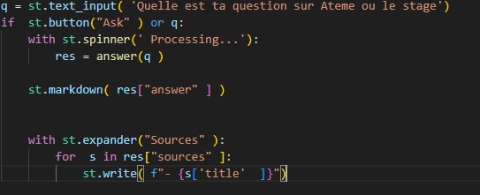
The streamlit app running is explained in the README.md but if you already done all the import and run the ingest.py, just run the following command: streamlit run ui/streamlit_app and a page will automatically open. If not just copy paste the url in your terminal.
You should have this:

Conclusion

